Lab work week 2 by Jishnu Matharu M01116516

Notes:
Truth table:
P | Q | P & Q | P | Q | P ^ Q
0 | 0 | 0 | 0 | 0
0 | 1 | 0 | 1 | 1
1 | 1 | 1 | 1 | 0
1 | 0 | 0 | 1 | 1

EX 1: Understanding Digital Logic (bitwise operators)
Program 1:
A = 12 = 0000 1100
B = 25 = 0001 1001

0000 1100
0001 1001 &
---------------
0000 1000 = 8
Output it 8

Program 2:
A = 12
B = 25

0000 1100
0001 1001 |
---------------
0001 1101 = 29
Output = 29

Program 3:
A = 12
B = 25

0000 1100
0001 1001 ^
----------------
0001 0101 = 21

Output = 21

Ex 2 Introduction to digital logic
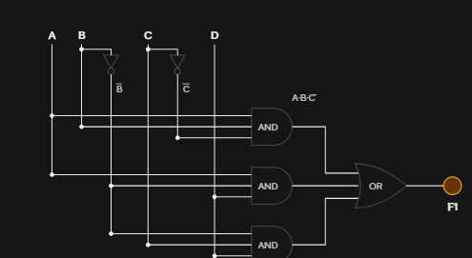

Ex 3:

Gate A:
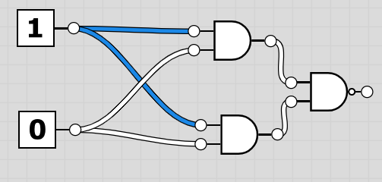

Both AND gates compute the same thing (A·B), so the NAND just sees the same value on both inputs. Since X·X = X, the second AND gate is redundant, and the whole circuit behaves like a single NAND gate.

A | B | Q
0 | 0 | 1
0 | 1 | 1
1 | 0 | 1
1 | 1 | 0

The output is only 0 when both switches are on and 1 in every case because the gate is a NAND gate to the same switched, its bulb always matches Q

Logic gates 2:
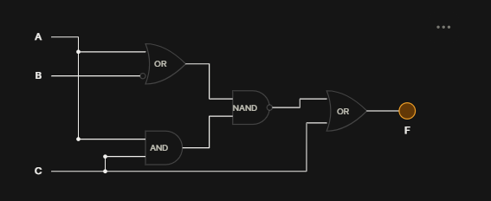
Boolean expression for B:
F = [ (A + B̄) · (A·C) ]‾ + C
Simplification:
- (A + B̄)·(A·C) = A·C, by absorption. Whenever A·C is 1, A is 1, so A + B̄ is also 1.
- The NAND therefore gives (A·C)‾ = Ā + C̄.
- F = Ā + C̄ + C. Since C̄ + C = 1, F = 1.
A | B | C | A + B | A.C | NAND | F
0 | 0 | 0 | 1 | 0 | 1 | 1
0 | 0 | 1 | 1 | 0 | 1 | 1
0 | 1 | 0 | 0 | 0 | 1 | 1
0 | 1 | 1 | 0 | 0 | 1 | 1
1 | 0 | 0 | 1 | 0 | 1 | 1
1 | 0 | 1 | 1 | 1 | 0 | 1
1 | 1 | 0 | 1 | 0 | 1 | 1
1 | 1 | 1 | 1 | 1 | 0 | 1

EX 4: Understanding of digital logic in a C program

#include <stdio.h>

/* Each gate takes bits (0 or 1) and returns 0 or 1. */
int and_gate(int a, int b) { return a & b; }
int or_gate(int a, int b) { return a | b; }
int xor_gate(int a, int b) { return a ^ b; }
int not_gate(int a) { return !a; } /* logical NOT, not bitwise ~ */

int main(void)
{
int a, b;

printf("Enter two binary digits (0 or 1), separated by a space: ");
if (scanf("%d %d", &a, &b) != 2 || (a != 0 && a != 1) || (b != 0 && b != 1)) {
printf("Invalid input: please enter only 0 or 1.\n");
return 1;
}

printf("\nResults for A = %d, B = %d\n", a, b);
printf("A AND B = %d\n", and_gate(a, b));
printf("A OR B = %d\n", or_gate(a, b));
printf("A XOR B = %d\n", xor_gate(a, b));
printf("NOT A = %d\n", not_gate(a));
printf("NOT B = %d\n", not_gate(b));

/* Full truth table, to compare against the output above. */
printf("\nTruth table\n");
printf(" A B | AND OR XOR | NOT A NOT B\n");
printf("-----+------------+------------\n");
for (int i = 0; i < 2; i++) {
for (int j = 0; j < 2; j++) {
printf(" %d %d | %d %d %d | %d %d\n",
i, j,
and_gate(i, j), or_gate(i, j), xor_gate(i, j),
not_gate(i), not_gate(j));
}
}

return 0;
}

EX 5:
#include <stdio.h>

int main(void)
{
int age;

printf("Enter your age:");
if (scanf("%d", &age) != 1) {
printf("\nInvalid input: please enter a whole number.\n");
return 1;
}

if (age >= 18) {
printf("You are eligible for voting\n");
} else {
printf("You are not eligible for voting\n");
}

return 0;
}

Ex 6:
#include <stdio.h>

int main() {
int num1, num2;

printf("Enter two integers: ");
scanf("%d %d", &num1, &num2);

if (num1 < num2) {
printf("Result: %d < %d\n", num1, num2);
}
else if (num1 > num2) {
printf("Result: %d > %d\n", num1, num2);
}
else {
printf("Result: %d = %d\n", num1, num2);
}

return 0;
}

EX 7 Basic C Code for pointers concept I:

#include <stdio.h>

int main() {
int c, *pc, **ppc;

c = 12;
pc = &c;
ppc = &pc;

printf("c = %d\n", c);
printf("pc = %p, the value pc points to = %d\n",
(void *)pc, *pc);
printf("ppc = %p, the value ppc points to = %d\n",
(void *)ppc, **ppc);

return 0;
}

EX 8 Basic C code for pointers concept 2:

Exercise 2:

